Unlimited Golf &
All Inclusive Vacation
www.CancunGolf.net

Unlimited Green Fees & Cart * Five-Stars Resorts * All Inclusive Meals and Drinks * Hotel Taxes & Gratuities Included * Numerous Restaurants and Amenities *
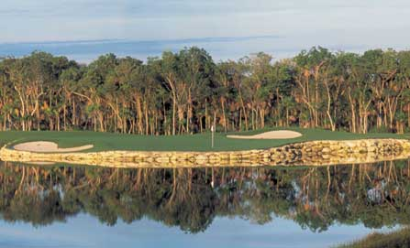
A Jack Nicklaus Signature Golf Course in Cancun
Jack Nicklaus said "Our goal was to design a golf course that would be fun and memorable to players of all levels".
Come play the signature hole; a 141-yard, par 3, that plays downwind to an island green. No place to bail out, it is either the green or the drink.
The Robert Von Hagge Playacar Golf Course
This magnificent golf course is close to the ocean and the fine white sands of the Caribbean Sea. Its inspired setting is the Mayan jungle, awarding golfers with a competitive round surrounded by lush foliage and aquamarine waters.

One price all inclusive vacation…play for FREE every day!!!
That's right! Your rounds of golf will cost you $0, zilch, nada!

The Moon Palace, the Playacar Palace, and other luxury resorts!
Unlimited golf * All Inclusive Food & beverages (alcoholic & non-alcoholic) *
Swim up bars * Complimentary tours * Live evening shows * Activities for kids * Doctor on call

Your vacation with unlimited golf starts at only $177 per person per night
Contact us for more details:
www.CancunGolf.net info@CancunGolf.net (786) 271-7952

